Edge Detection

Part 1:

Edge detection is a technique of image processing used to identify points in a digital image with discontinuities, simply to say, sharp changes in the image brightness. These points where the image brightness varies sharply are called the edges (or boundaries) of the image.

## Edge Detection

The Sobel operator is used in image processing and computer vision, particularly within edge detection algorithms where it creates an image emphasizing edges.

$G_{x}=\left[\begin{matrix}+1 & 0 & -1 \\ +2 & 0 & -2 \\ +1 & 0 & -1\end{matrix}\right]$ and $G_{y}=\left[\begin{matrix}+1 & +2 & +1 \\ 0 & 0 & 0 \\ -1 & -2 & -1\end{matrix}\right]$

$G_{x}=\left[\begin{matrix}-5 & -4 & 0 & +4 & +5 \\ -8 & -10 & 0 & +10 & +8 \\ -10 & -20 & 0 & +20 & +10 \\ -8 & -10 & 0 & +10 & +8 \\ -5 & -4 & 0 & +4 & +5\end{matrix}\right]$ and $G_{y}=\left[\begin{matrix}-5 & -8 & -10 & -8 & -5 \\ -4 & -10 & -20 & -10 & -4 \\ 0 & 0 & 0 & 0 & 0 \\ +4 & +10 & +20 & +10 & +4 \\ +5 & +8 & +10 & +8 & +5\end{matrix}\right]$

**Parameters**

|  |  |  |
| --- | --- | --- |
| src: | Address of source image | |
| tgt: | Modified image is saved in this address | |
| Input Vector: | roi_number | Number of defined ROI |
| ROI | Coordinate of target pixels |
| ws | Window size of kernel |

### **Example**

baboon.pgm baboon_edge.pgm edge 2 0 0 100 400 3 300 150 200 350 5

|  |  |  |
| --- | --- | --- |
| Image Address | baboon.pgm | Address of input image |
| baboon_edge.pgm | Address of modified image |
| Function | edge | Function name |
| ROI | 2 | Number of ROI |
| First Input | 0 | Coordinate of up-left X of 1st ROI |
| 0 | Coordinate of up-left Y of 1st ROI |
| 100 | Length of 1st ROI |
| 400 | Width of 1st ROI |
| 3 | Window size |
| Second Input | 300 | Coordinate of up-left X of 2ed ROI |
| 150 | Coordinate of up-left Y of 2ed ROI |
| 200 | Length of 2ed ROI |
| 350 | Width of 2ed ROI |
| 5 | Window size |

### **Output**

Edge detection with 2 ROIs (ROI1: left, ROI2: right)

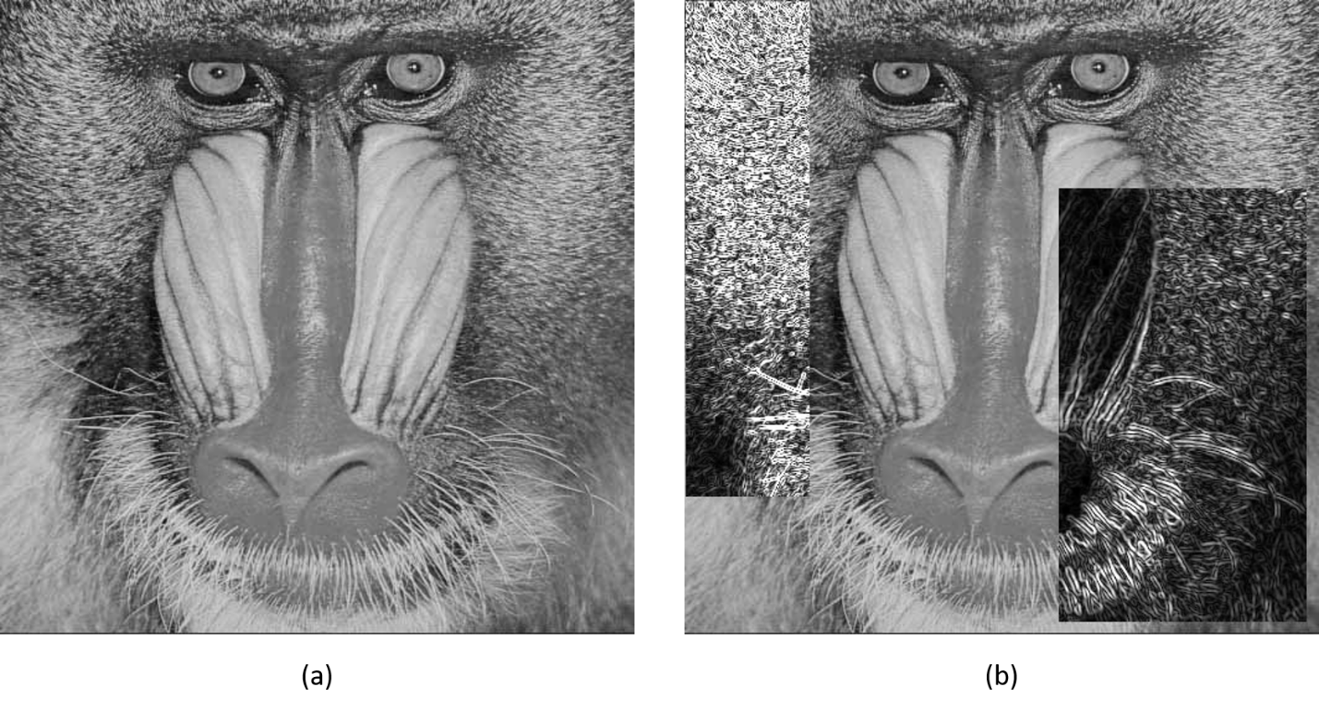

Figure 1 (a) Original Image (b) Modified Image

1. Original image
2. Window Size: 3 for ROI1

Window Size: 5 for ROI2

## Threshold Edge Detection

Threshold edge detection is combination of edge detection and binarizing. This function points the edges of images using Sobel filter and then, binarize the result based on user provided threshold.

**Parameters**

|  |  |  |
| --- | --- | --- |
| src: | Address of source image | |
| tgt: | Modified image is saved in this address | |
| Input Vector: | roi_number | Number of defined ROI |
| ROI | Coordinate of target pixels |
| ws | Window size (3 or 5) |
|  | th | Threshold |

### **Example**

baboon.pgm baboon_tedge.pgm tedge 2 0 0 100 400 3 120 300 150 200 350 5 160

|  |  |  |
| --- | --- | --- |
| Image Address | baboon.pgm | Address of input image |
| baboon_tedge.pgm | Address of modified image |
| Function | tedge | Function name |
| ROI | 2 | Number of ROI |
| First Input | 0 | Coordinate of up-left X of 1st ROI |
| 0 | Coordinate of up-left Y of 1st ROI |
| 100 | Length of 1st ROI |
| 400 | Width of 1st ROI |
| 3 | Window size |
| 120 | Threshold |
| Second Input | 300 | Coordinate of up-left X of 2ed ROI |
| 150 | Coordinate of up-left Y of 2ed ROI |
| 200 | Length of 2ed ROI |
| 350 | Width of 2ed ROI |
| 5 | Window size |
| 160 | Threshold |

### **Output**

Edge detection with 2 ROIs (ROI1: left, ROI2: right)

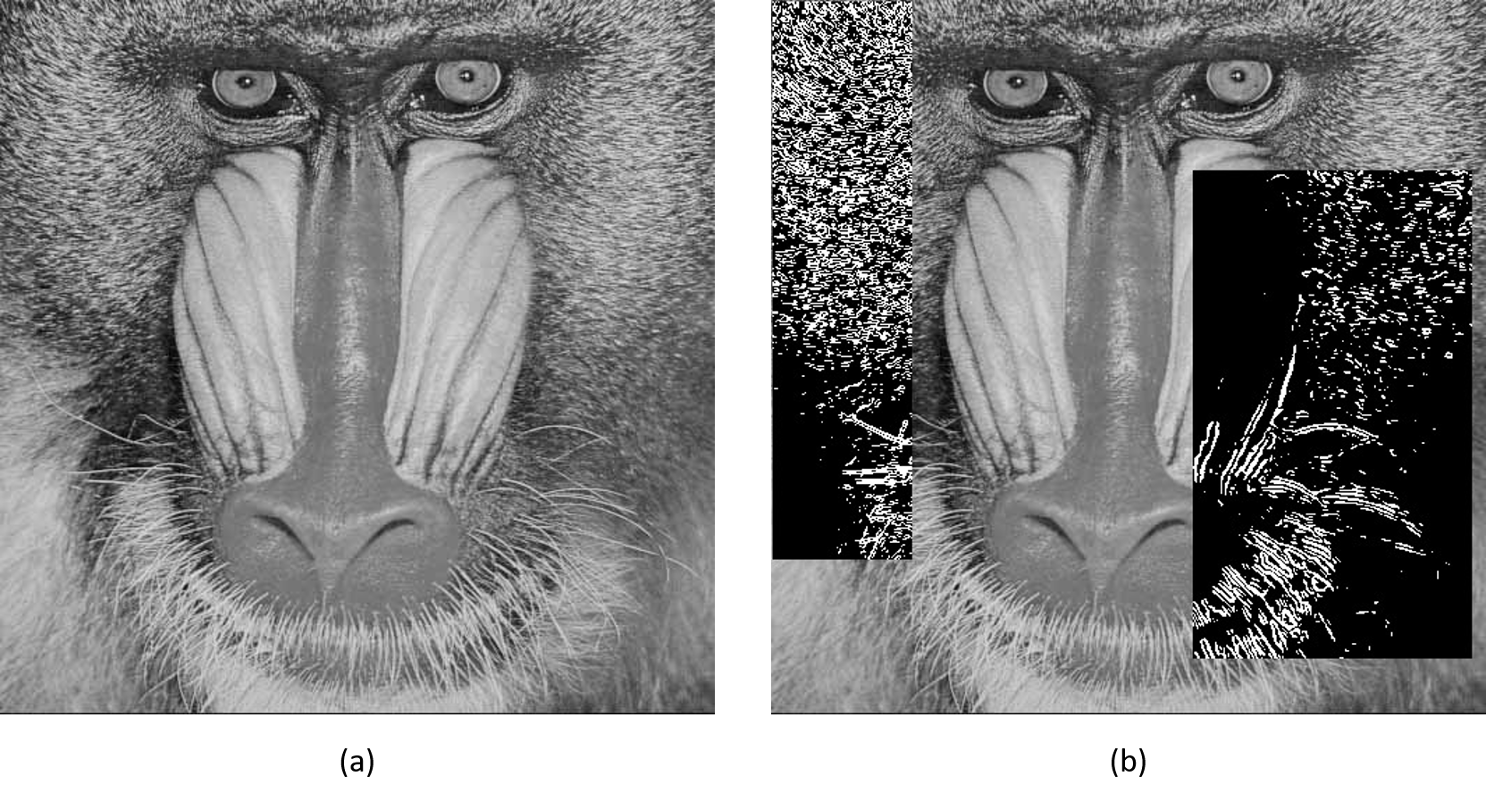

Figure 3 (a) Original Image (b) Modified Image

1. Original image
2. Window Size = 3 and Threshold = 120 for ROI1

Window Size = 5 and Threshold = 160 for ROI2

## Color Edge Detection

Threshold edge detection is combination of edge detection and binarizing. This function points the edges of images using Sobel filter and then, binarize the result based on user provided threshold.

**Parameters**

|  |  |  |
| --- | --- | --- |
| src: | Address of source image | |
| tgt: | Modified image is saved in this address | |
| Input Vector: | roi_number | Number of defined ROI |
| ROI | Coordinate of target pixels |
| ws | Window size (3 or 5) |
|  | th | Threshold |

### **Example**

baboon.pgm baboon_cedge.pgm cedge 2 0 0 100 400 3 300 150 200 350 5

|  |  |  |
| --- | --- | --- |
| Image Address | baboon.pgm | Address of input image |
| baboon_cedge.pgm | Address of modified image |
| Function | cedge | Function name |
| ROI | 2 | Number of ROI |
| First Input | 0 | Coordinate of up-left X of 1st ROI |
| 0 | Coordinate of up-left Y of 1st ROI |
| 100 | Length of 1st ROI |
| 400 | Width of 1st ROI |
| 3 | Window size |
| Second Input | 300 | Coordinate of up-left X of 2ed ROI |
| 150 | Coordinate of up-left Y of 2ed ROI |
| 200 | Length of 2ed ROI |
| 350 | Width of 2ed ROI |
| 5 | Window size |

### **Output**

Color edge detection with 2 ROIs (ROI1: left, ROI2: right)

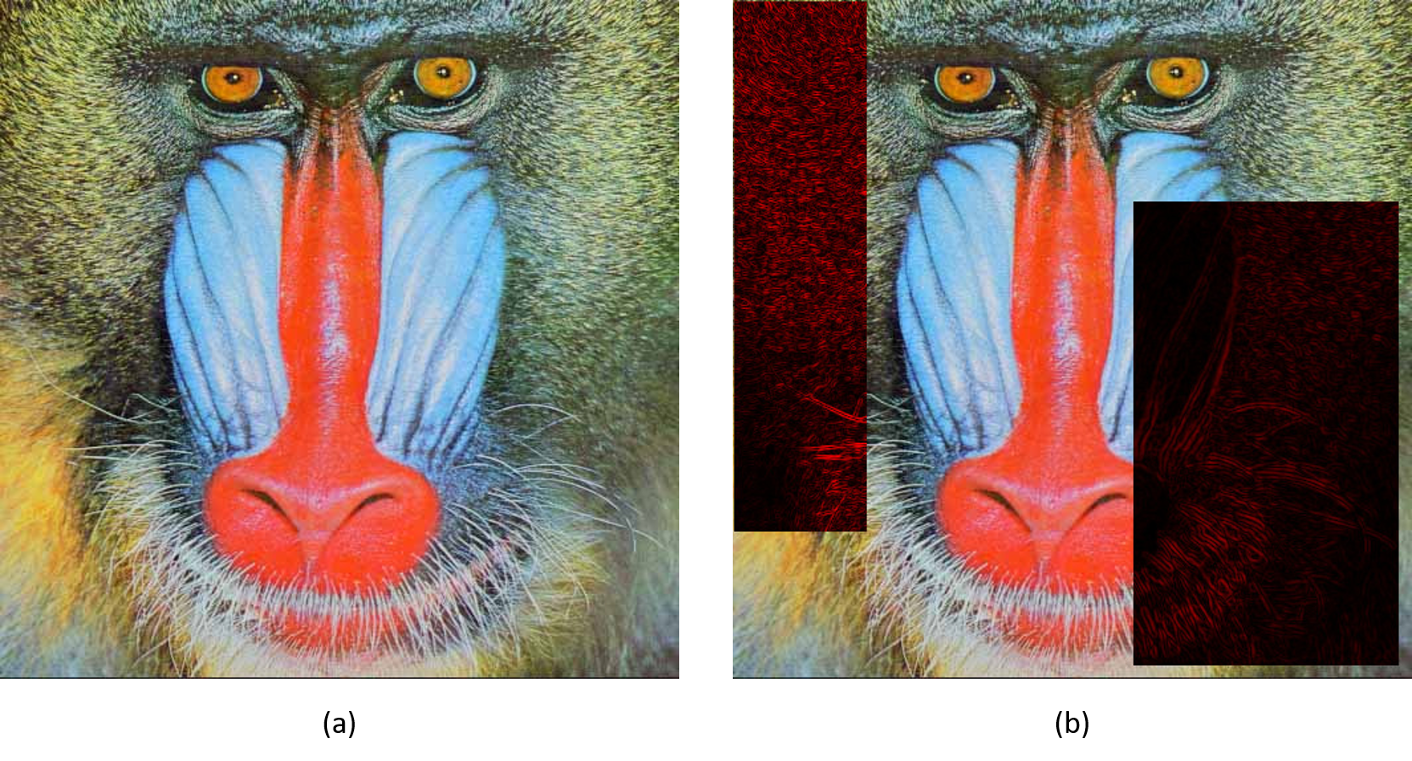

Figure 3 (a) Original Image (b) Modified Image

1. Original image
2. Window Size: 3 for ROI1

Window Size: 5 for ROI2

## Direction Edge Detection

Direction edge detection is combination of edge in 45-degree detection and binarizing. This function points the edges in 45-degree using Sobel filter and then, binarize the result based on user provided threshold.

**Parameters**

|  |  |  |
| --- | --- | --- |
| src: | Address of source image | |
| tgt: | Modified image is saved in this address | |
| Input Vector: | roi_number | Number of defined ROI |
| ROI | Coordinate of target pixels |
| ws | Window size (3 or 5) |
|  | th | Threshold |

### **Example**

wheel.pgm wheel_diredge.pgm diredge 1 0 0 300 195 5 50

|  |  |  |
| --- | --- | --- |
| Image Address | wheel.pgm | Address of input image |
| wheel_diredge.pgm | Address of modified image |
| Function | diredge | Function name |
| ROI | 1 | Number of ROI |
| First Input | 0 | Coordinate of up-left X of 1st ROI |
| 0 | Coordinate of up-left Y of 1st ROI |
| 300 | Length of 1st ROI |
| 295 | Width of 1st ROI |
| 5 | Window size |
| 50 | Threshold |

### **Output**

Edge detection with 2 ROIs (ROI1: left, ROI2: right)

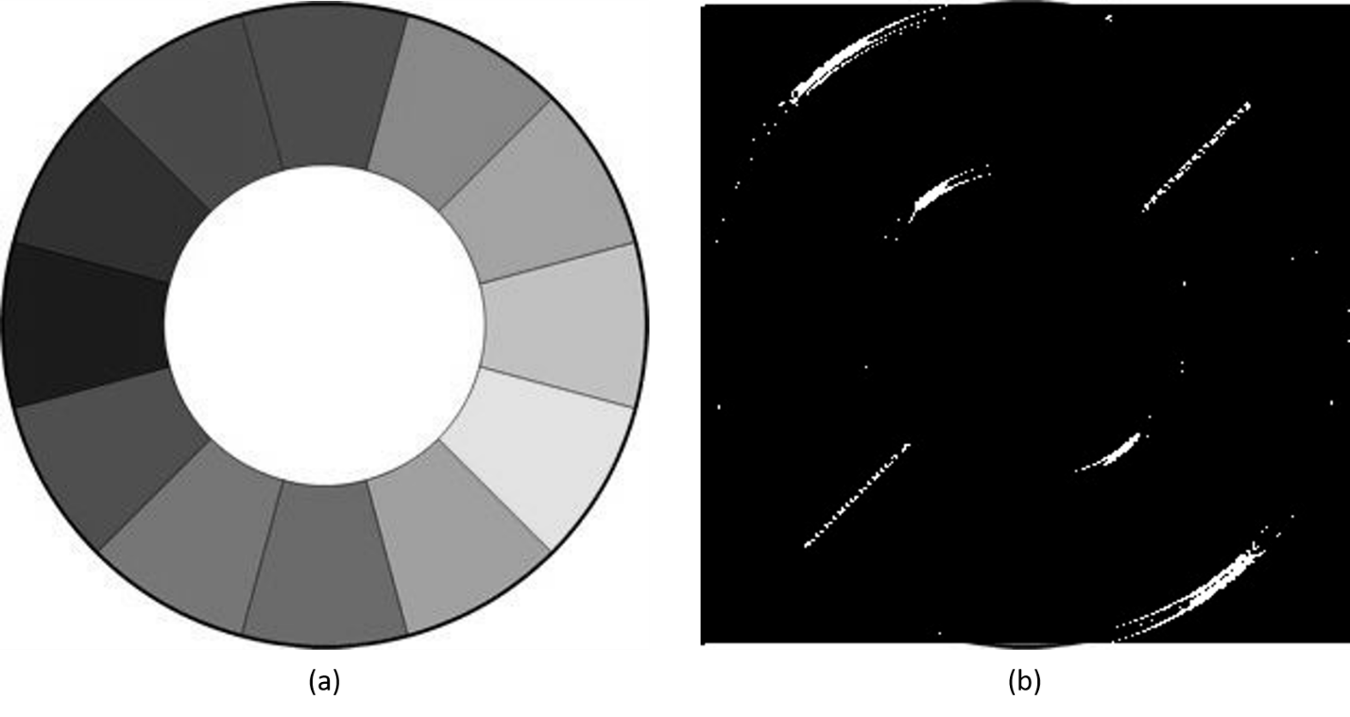

Figure 3 (a) Original Image (b) Modified Image

1. Original image
2. Window Size = 3 and Threshold = 120 for ROI1

Window Size = 5 and Threshold = 160 for ROI2

Part 2:

OpenCV is a library of programming functions mainly aimed at real-time computer vision. In this part, we will implement some functions that used to be implemented.

## Sobel Edge Detection

In this part we will use Sobel model of OpenCV.

**Parameters**

|  |  |  |
| --- | --- | --- |
| src: | Address of source image | |
| tgt: | Modified image is saved in this address | |
| Input Vector: | roi_number | Number of defined ROI |
| ROI | Coordinate of target pixels |
| ws | Window size of kernel |

### **Example**

baboon.pgm baboon_sobel.pgm sobel 2 0 0 100 400 3 300 150 200 350 5

|  |  |  |
| --- | --- | --- |
| Image Address | baboon.pgm | Address of input image |
| baboon_sobel.pgm | Address of modified image |
| Function | sobel / csobel | Function name |
| ROI | 2 | Number of ROI |
| First Input | 0 | Coordinate of up-left X of 1st ROI |
| 0 | Coordinate of up-left Y of 1st ROI |
| 100 | Length of 1st ROI |
| 400 | Width of 1st ROI |
| 3 | Window size |
| Second Input | 300 | Coordinate of up-left X of 2ed ROI |
| 150 | Coordinate of up-left Y of 2ed ROI |
| 200 | Length of 2ed ROI |
| 350 | Width of 2ed ROI |
| 5 | Window size |

### **Output**

Edge detection with 2 ROIs (ROI1: left, ROI2: right)

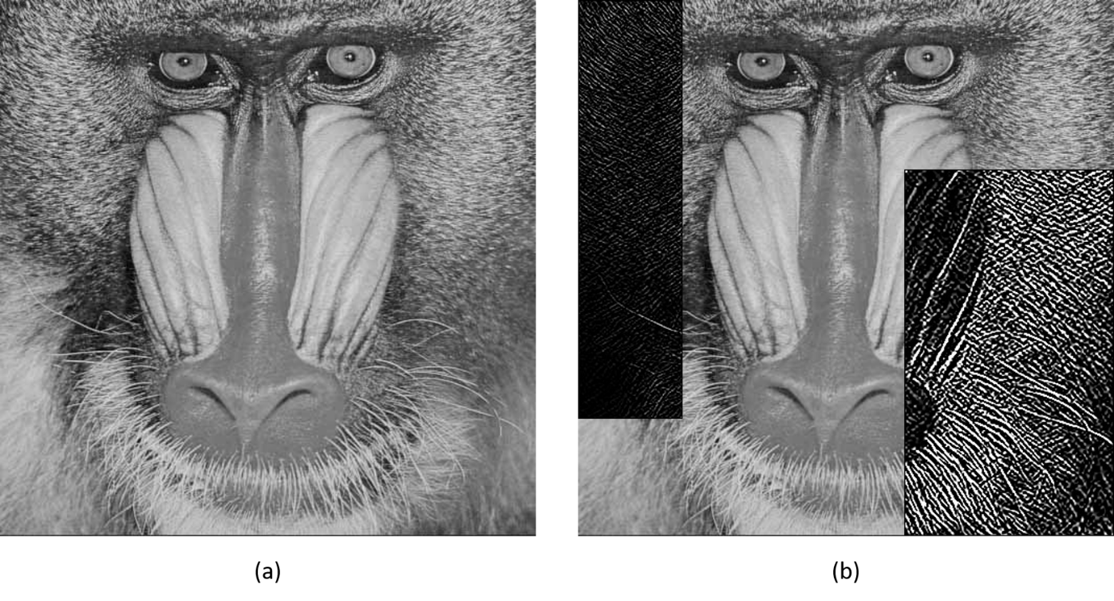

Figure 1 (a) Original Image (b) Modified Image

1. Original image
2. Window Size: 3 for ROI1

Window Size: 5 for ROI2

My edge detection and OpenCV Sobel function results are acceptable. But the edges in the OpenCV module are sharper than my fuction.

## Canny Edge Detection

In this part we will use Canny model of OpenCV.

**Parameters**

|  |  |  |
| --- | --- | --- |
| src: | Address of source image | |
| tgt: | Modified image is saved in this address | |
| Input Vector: | roi_number | Number of defined ROI |
| ROI | Coordinate of target pixels |
| ws | Window size of kernel |

### **Example**

baboon.pgm baboon_canny.pgm canny 2 0 0 100 400 3 300 150 200 350 5

|  |  |  |
| --- | --- | --- |
| Image Address | baboon.pgm | Address of input image |
| baboon_canny.pgm | Address of modified image |
| Function | canny / ccanny | Function name |
| ROI | 2 | Number of ROI |
| First Input | 0 | Coordinate of up-left X of 1st ROI |
| 0 | Coordinate of up-left Y of 1st ROI |
| 100 | Length of 1st ROI |
| 400 | Width of 1st ROI |
| 3 | Window size |
| Second Input | 300 | Coordinate of up-left X of 2ed ROI |
| 150 | Coordinate of up-left Y of 2ed ROI |
| 200 | Length of 2ed ROI |
| 350 | Width of 2ed ROI |
| 5 | Window size |

### **Output**

Edge detection with 2 ROIs (ROI1: left, ROI2: right)

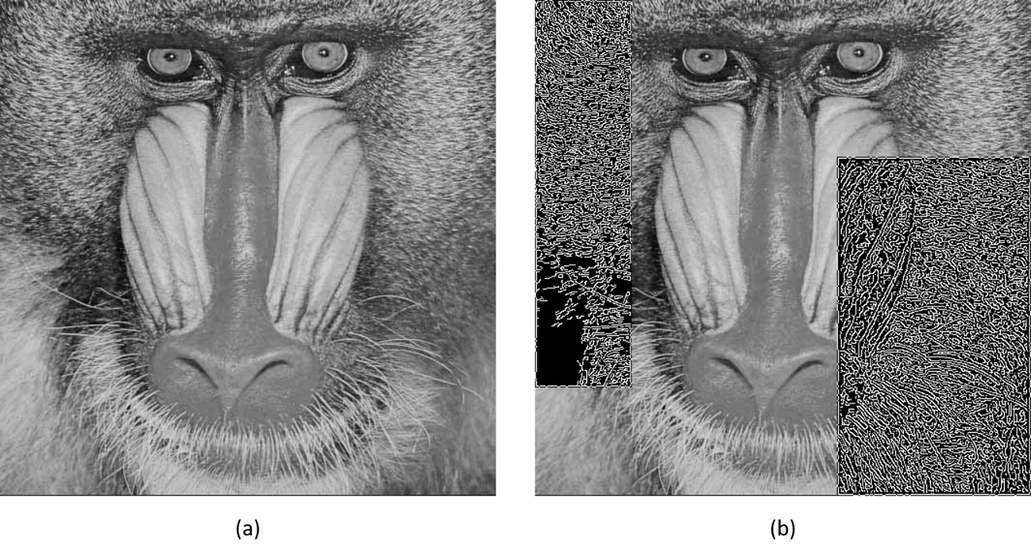

Figure 1 (a) Original Image (b) Modified Image

1. Original image
2. Window Size: 3 for ROI1

Window Size: 5 for ROI2

Edges in Canny module are sharper and more clear than Sobel module.

## Histogram Equalization

Histogram equalization is a method in image processing of contrast adjustment using the image's histogram. In this part we will use equalization model of OpenCV.

**Parameters**

|  |  |  |
| --- | --- | --- |
| src: | Address of source image | |
| tgt: | Modified image is saved in this address | |
| Input Vector: | roi_number | Number of defined ROI |
| ROI | Coordinate of target pixels |

### **Example**

baboon.pgm baboon_eq.pgm equalization 2 0 0 100 400 3 300 150 200 350 5

|  |  |  |
| --- | --- | --- |
| Image Address | baboon.pgm | Address of input image |
| baboon_eq.pgm | Address of modified image |
| Function | equalization / cequalization | Function name |
| ROI | 2 | Number of ROI |
| First Input | 0 | Coordinate of up-left X of 1st ROI |
| 0 | Coordinate of up-left Y of 1st ROI |
| 100 | Length of 1st ROI |
| 400 | Width of 1st ROI |
| Second Input | 300 | Coordinate of up-left X of 2ed ROI |
| 150 | Coordinate of up-left Y of 2ed ROI |
| 200 | Length of 2ed ROI |
| 350 | Width of 2ed ROI |

### **Output**

Histogram equalization with 2 ROIs (ROI1: left, ROI2: right)

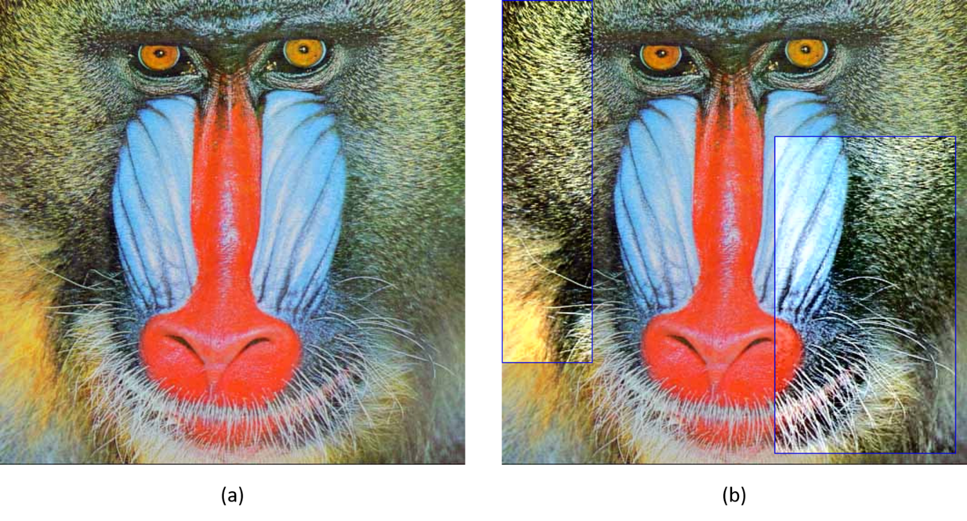

Figure 1 (a) Original Image (b) Modified Image

1. Original image
2. Equalized Image

The Histogram equalization makes image sharper and brighter. While the histogram stretching just make a little change in picture. Because histogram stretching adjust all pixels in same value.

## Extract Foreground

Foreground extract is any technique which allows an image’s foreground to be extracted for further processing like object recognition, tracking etc.

The algorithm exhaustively searches for the threshold that minimizes the intra-class variance, defined as a weighted sum of variances of the two classes.

**Parameters**

|  |  |  |
| --- | --- | --- |
| src: | Address of source image | |
| tgt: | Modified image is saved in this address | |
| Input Vector: | roi_number | Number of defined ROI |
| ROI | Coordinate of target pixels |

### **Example**

coin.pgm coin_otsu.pgm otsu 1 0 0 500 320

|  |  |  |
| --- | --- | --- |
| Image Address | coin.pgm | Address of input image |
| coin_otsu.pgm | Address of modified image |
| Function | otsu | Function name |
| ROI | 2 | Number of ROI |
| First Input | 0 | Coordinate of up-left X of 1st ROI |
| 0 | Coordinate of up-left Y of 1st ROI |
| 500 | Length of 1st ROI |
| 320 | Width of 1st ROI |

### **Output**

Foreground extracting by Otsu thresholding with 2 ROIs (ROI1: left, ROI2: right)

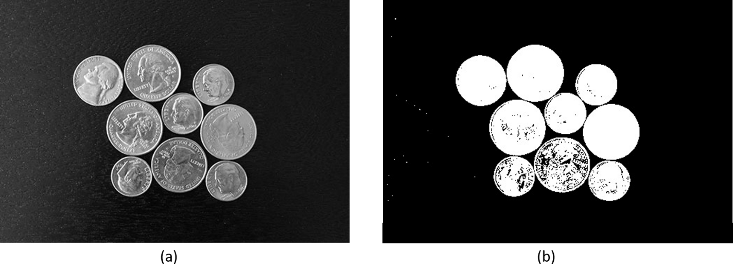

Figure 1 (a) Original Image (b) Modified Image

1. Original image
2. Foreground Extraction

Adaptive threshold is much better than fixed threshold. If the brightness in some part of image be different extremely, fixed threshold could not extract the foreground and background.